450 Seventh Avenue Suite 2805 New York, NY 10123
Tel: 212 947-5500 Fax: 212 279-8707 E-mail: Midcomre@aol.com

Date: <<Today’s Date>>

EXCLUSIVE AGREEMENT TO LEASE YOUR SPACE
<<Tenant Name>>
<<Tenant Company Name>>
<Tenant Address>>
<<Tenant Phone Number>>
<<Tenant E-mail Address>>

Dear <<Tenant Name>>;

We are happy to represent you in the leasing of the <<Leasing Floor Number>> floor available space in your building, and any other spaces
you choose to ask us to lease. This paper will outline the terms and conditions of the tenancy, and the payment of commission to MCRE upon it’s successful completion of this assignment.

Building: <<Property Address>> Space: <<Space Name>>

Size: Approximately <<Rentable Square Feet>> rentable square feet. Insurance: $ <<Insurance Cost>>

Term: <<Five or Ten Year Term>> Year Term Lease Commencement: <<Date of lease commencement>>

Rent: $<<Cost per square foot base rent>> per square foot base rent $<<Cost per annum>> per annum

Electricity: <<Electricity Cost>> Other: <<Other Electricity Cost>> Fuel Surcharge: <<Fuel Surcharge Cost>>

Water: <<Water Cost per month>> per month Sprinkler: <<Sprinkler Cost per month>> per month

Heat: <<Heat cost per month>> A/C: <<A/C Cost Per Month>>

Escalations: <<Escalations percent starting in second year of lease>>% starting in second year of lease.

Security: <<Number of months rent for secuity (Number)>> ( <<Number of months rent for security (Spelled Out)>>) months rent (subject to review of financials)

Landlord agrees to work ONLY with Midtown Commercial Real Estate (MCRE) for a period of One hundred eighty days (180) days while MCRE markets, advertises, and offers the property for lease to Users, Brokers, and all interested parties.

During this time MCRE will advertise the property on all appropriate internet / web sites, newspapers & periodicals, and market to all brokers, and end-users that meet client's criteria.

Landlord will notify any Potential Tenants or Brokers that contact them that MCRE is the exclusive broker for the above referenced space/s, and that MCRE will be happy to supply appropriate information and arrange a tour of the space for all qualified parties. MCRE will accept offers from Tenants or their agents, and negotiate all terms and conditions of a Lease and present offers to Landlord for counteroffers and or approval.

Landlord will be responsible for paying one full brokerage fee to MCRE upon signing of a Lease, payment of security, first month's Rent and Tenant taking possession of the space.

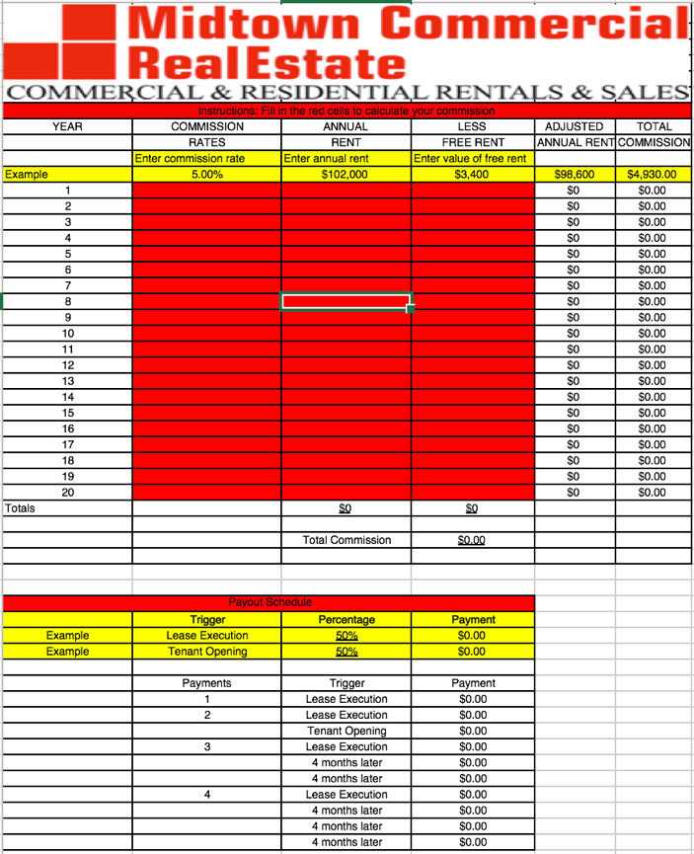

Commission rates are detailed below which are calculated on the gross leasing rent for each year's cumulative rental less any concession of free time allocated over the term of the lease. This fee is to be paid 50% at signing and 50% upon Tenant's payment of second month rent. If an outside broker brings a tenant that leases this space Landlord will be responsible for paying one full and one half commission.

This agreement is for an initial period of 180 Days, and will begin on <<Beginning date of agreement>> and expire on <<Expiration date of agreement>> The agreement automatically renews unless either party gives a thirty day termination notice in writing .

The terms are binding upon the parties and their representatives, and assigns. After the date of termination of this agreement, Landlord will continue to recognize MCRE as its agent with any potential Tenants MCRE has already shown the property to, and in any negotiations then pending or begun, for one (1) additional year.

Broker warrants and represents that, under the laws of the State of New York, it is a duly licensed Real Estate Broker , and is in good standing. This agreement shall be governed by the laws of the State of New York.

If the above is in accordance with your understanding, please note your acceptance thereof by signing and returning to us the duplicate copy of this letter.

AGREED: _________________________ Date: _____

_________________________ Date: _____

Thank you,

Paul Stern, Licensed Real Estate Broker
<<Midtown Commercial Real Estate Representative Name>> Licensed Real Estate <<Midtown Commercial Real Estate Broker, Salesperson, or other (Please specify)>>
Midtown Commercial Real Estate

